MODULE: 1 (SDLC)

1. What is software? What is software engineering?

Ans - Software engineering has two parts: software and engineering. Software is **a collection of codes, documents, and triggers that does a specific job and fills a specific requirement**. Engineering is the development of products using best practices, principles, and methods.

2. Explain types of software

Ans - The two main **categories of software** are application **software** and system **software**. An application is **software** that fulfills a specific need or performs tasks.

3. What is SDLC? Explain each phase of SDLC

Ans - An SDLC (software development life cycle) is **a big-picture breakdown of all the steps involved in software creation (planning, coding, testing, deploying, etc.)**. Companies define custom SDLCs to create a predictable, iterative framework that guides the team through all major stages of development.

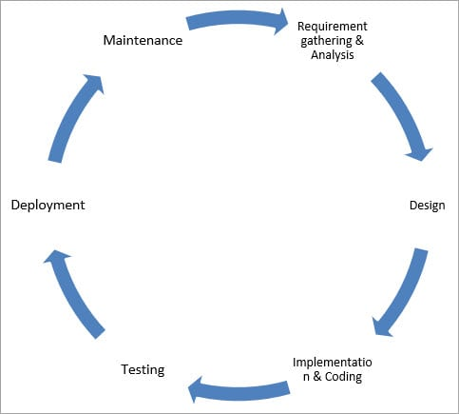

4. What is Flow chart? Create a flowchart to make addition of two numbers

Ans - Input : Two numbers a and b Step 1: Start Step 2: Declare sum to 0 (This is optional step, during step5 we can add declaration and assign directly as well) Step 3: Read number a Step 4: Read number b Step 5: Add a and b and assign result to variable sum Step 6: Print sum Step 7: Stop Output: Sum of a and b

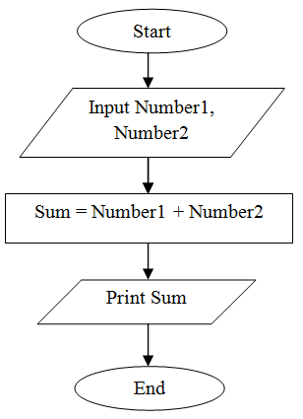

5. What is Use case Diagram? Create a use-case on bill payment on paytm.

Ans - Use-case diagrams **describe the high-level functions and scope of a system**. These diagrams also identify the interactions between the system and its actors. The use cases and actors in use-case diagrams describe what the system does and how the actors use it, but not how the system operates internally.

